WELCOME TO CS-521!!!

Tue - Thu, 6-7:30 p.m.

Lecture 7 (Nov 24, 2020)

Note: lecture 8 is on Sunday @10:00 am EST

Week 4:

Homework 4

Quiz 4

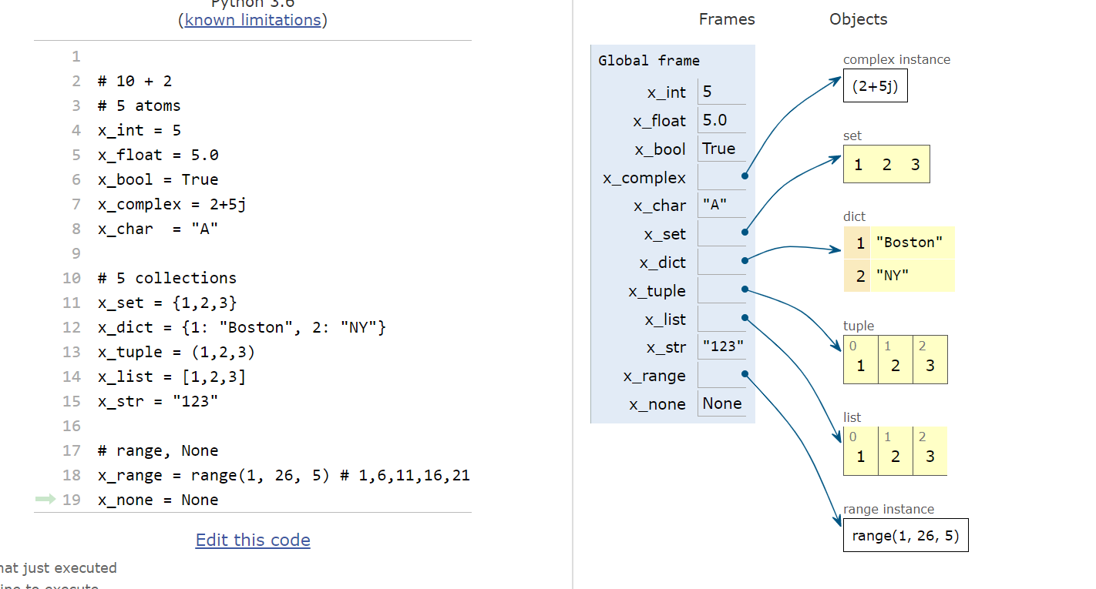

Example:

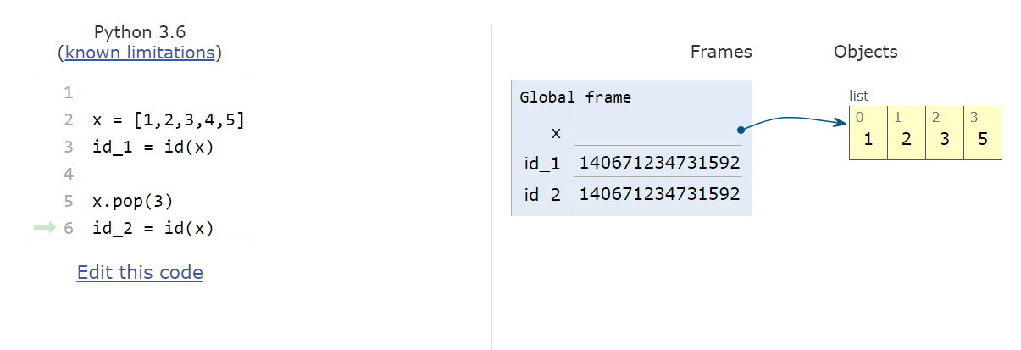

Task: given a sentence, reverse every second word

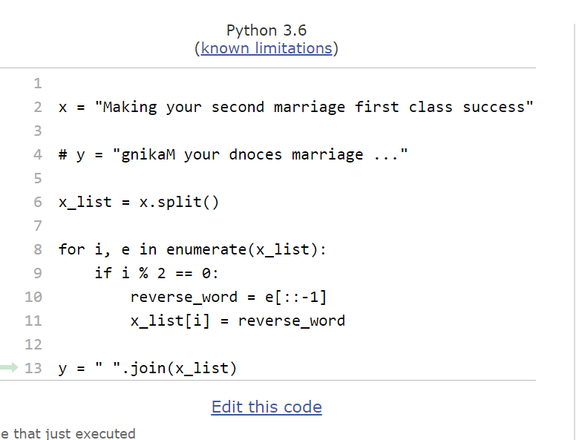

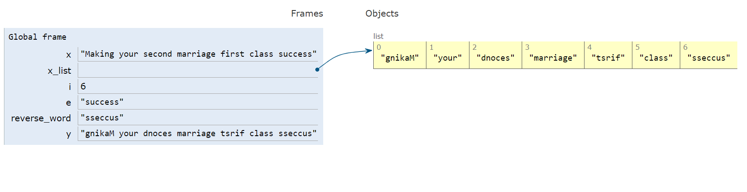

Example: real-estate translation

(translate real estate ads)

x = “charming cozy affordable space”

real meaning:

“dilapidated small expensive space”

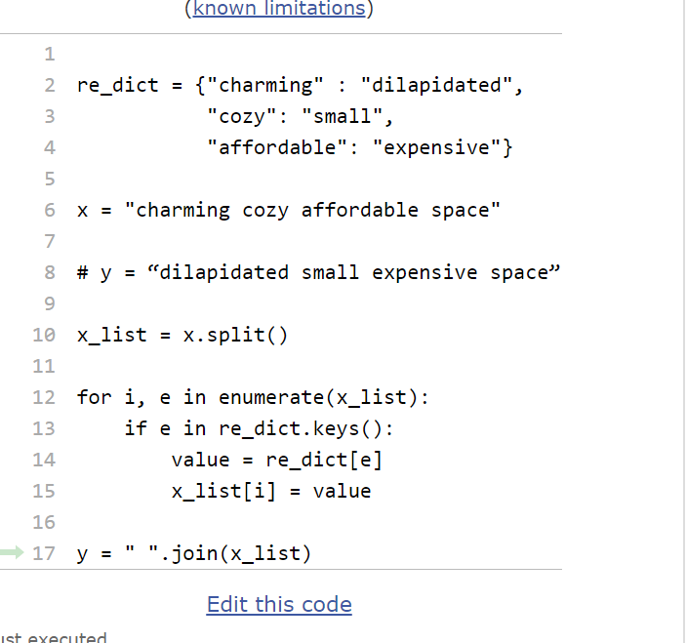

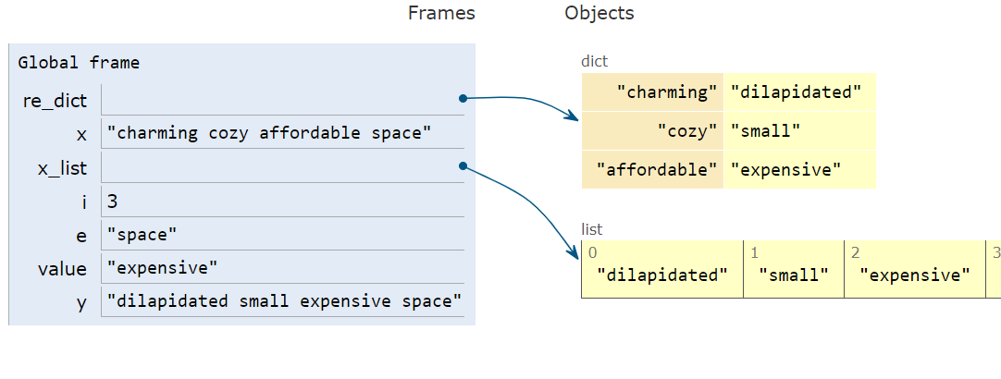

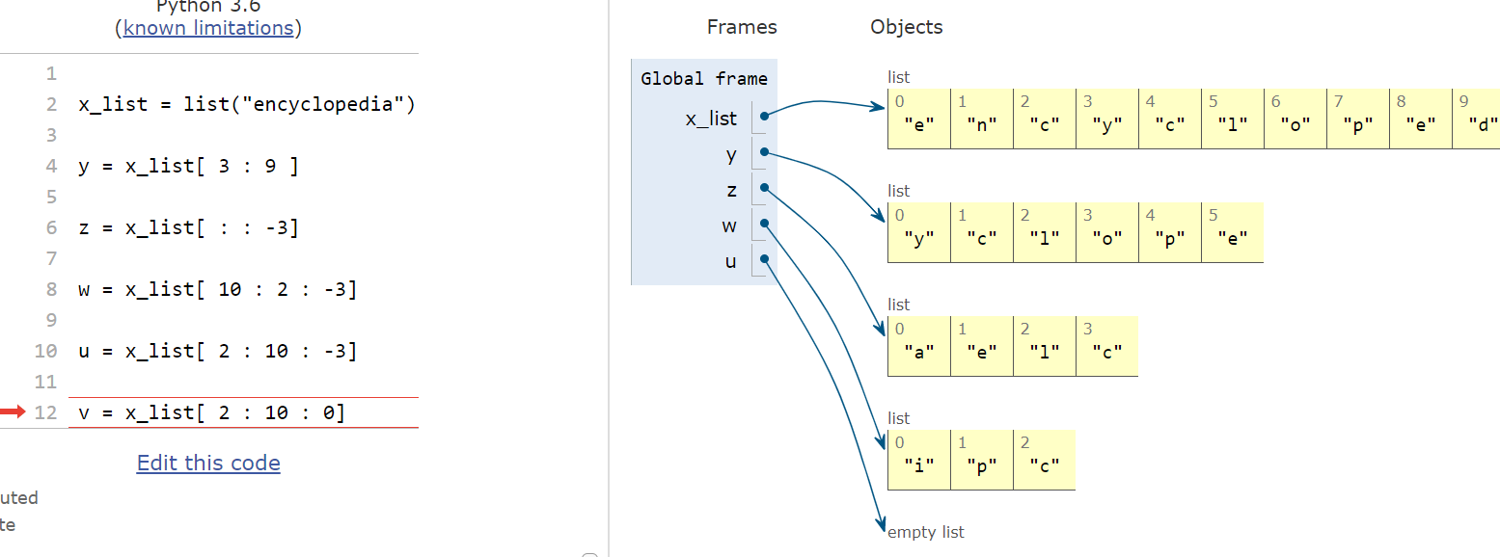

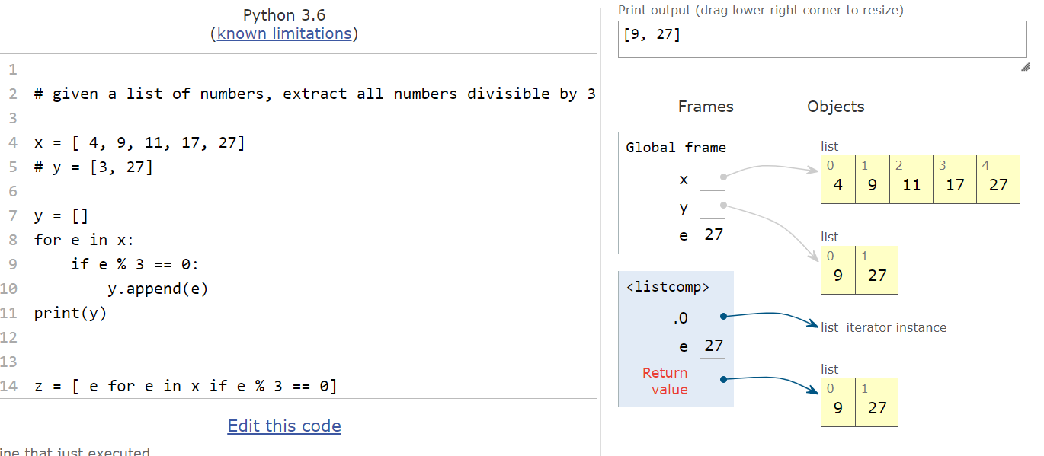

COMPREHENSION CONSTRUCT:

* exists only for mutable collections (lists, sets and dictionaries)
* shorthand for iteration with conditions
* still iteration, but more compact

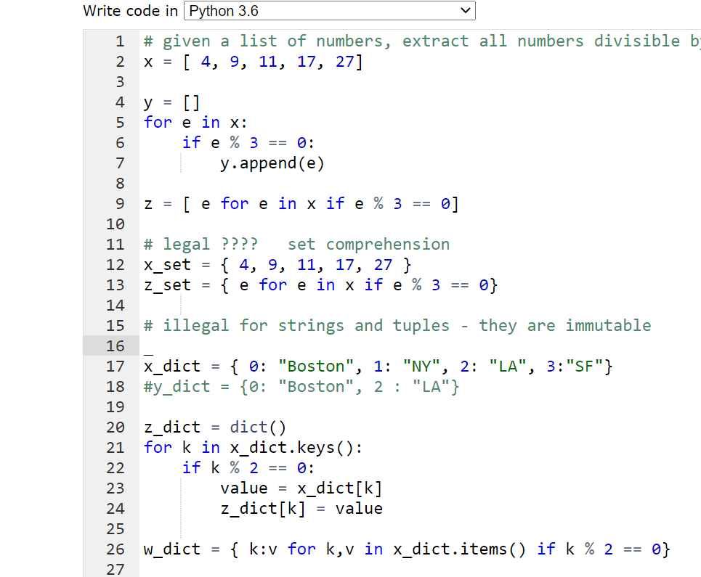

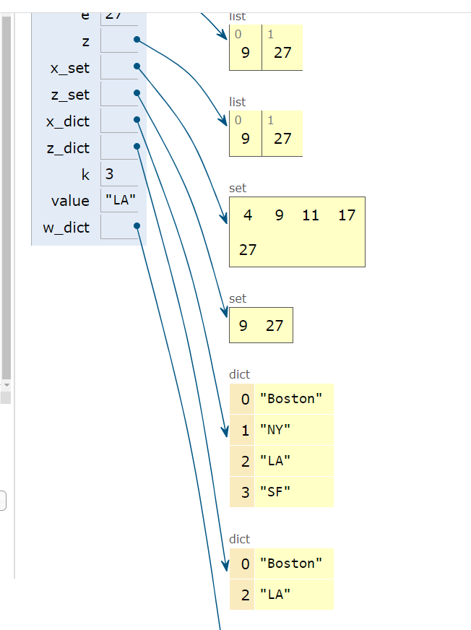

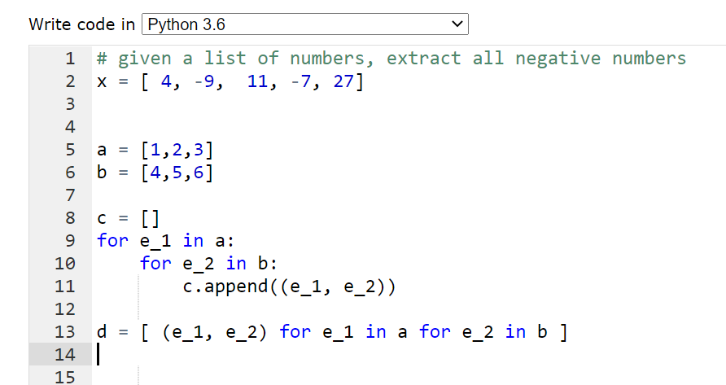

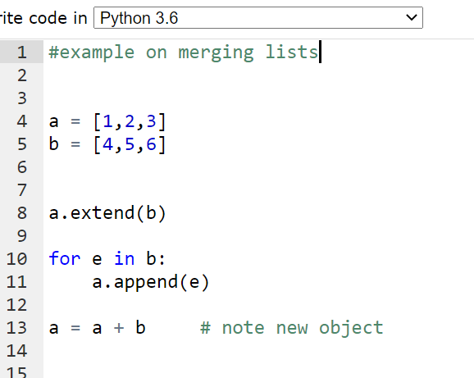

lists (similar to strings – ordered collections)

but they are mutable